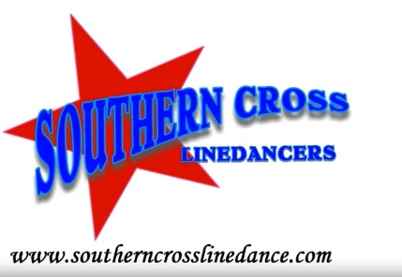
DIVE
Choreographed by Mark Simpkin - 2017
Music: Dive; Ed Sheeran
48 Counts 2 Walls, Intermediate Waltz Line Dance
Start on Vocals at 24 counts

# Restart after 12 counts on wall 4 and 8. Start the wall at 6.00 and restart 12.00
## At the end of wall 10 add - 1,2,3 Step fwd L, Drag R, Step R tog facing 12.00

1 – 6 | FWD L, 1/4 R, BACK L, BACK R, 1/2 L, FWD R
1, 2, 3 | Step fwd L, Making 1/4 turn L step R back, Step back L (9.00)
4, 5, 6 | Step back R, make 1/2 turn L step fwd L, Step fwd R (3.00)
7-12 | FWD L, SWEEP 1/4, CROSS R, SIDE, HINGE 1/2 R
1, 2, 3 | Step fwd L, making 1/4 turn L sweep R (2 counts) (12.00)
4, 5, 6 | Cross R over L, Step L to L side Hinge 1/2 turn over R, Step R to R side, (6.00) #
13 – 18 | CROSS L, REPLACE, SIDE L, CROSS R, REPLACE, SIDE R
1, 2, 3 | Cross/Lunge L over R, Replace wgt on R, Step L to L side
4, 5, 6 | Cross/Lunge R over L, Replace wgt on L, Step R to R side
19 - 24 | LARGE STEP L, DRAG, DRAG, ROLLING R 1/4, 1/2, 1/2,
1, 2, 3 | Large Step L to L side dragging R tog (2 counts)
4, 5, 6 | 1/4 turn R step R fwd, making 1/2 turn R step back L, making 1/2 turn R step fwd R (9.00)
25 – 30 | STEP FWD L, 3/4 SWEEP TURN R, BEHIND R, SIDE L, CROSS R
1, 2, 3 | Step fwd on L making 3/4 turn R, using momentum sweep R around (6.00)
4, 5, 6 | Step R behind L, step L to L, cross R over L
31 – 36 | LARGE STEP L, DRAG, TOUCH R TOG, SIDE R, TOG L, CROSS R
1, 2, 3 | Large step to L, Drag R to L, touch R tog
4, 5, 6 | Step R to R side, Step L tog, Cross R over L (slightly on diagonal) (scissor step)
37 – 42 | ROLLING L 1/4, 1/2, 1/2, STEP FWD R, 3/4 HOOK TURN L
1, 2, 3 | 1/4 turn L step fwd L, make 1/2 turn L step back R, make 1/2 turn L step fwd L (3.00)
4, 5, 6 | Step fwd on R, making 3/4 turn L (wgt on R) (2 counts) hooking L (6.00)
43 – 48 | FWD L COASTER, 1/2 R, BACK 1/2 L, FWD R
1, 2, 3 | Step fwd L, Step R tog, Step back L (fwd L coaster)
4, 5, 6 | Make1/2 turn R rock/step fwd R, Push back on L Make 1/2 turn R, Step fwd R ##
Mark Simpkin: msimpkin@bigpond.net.au – southerncrosslinedance.com YouTube – Southern Cross Linedancers

