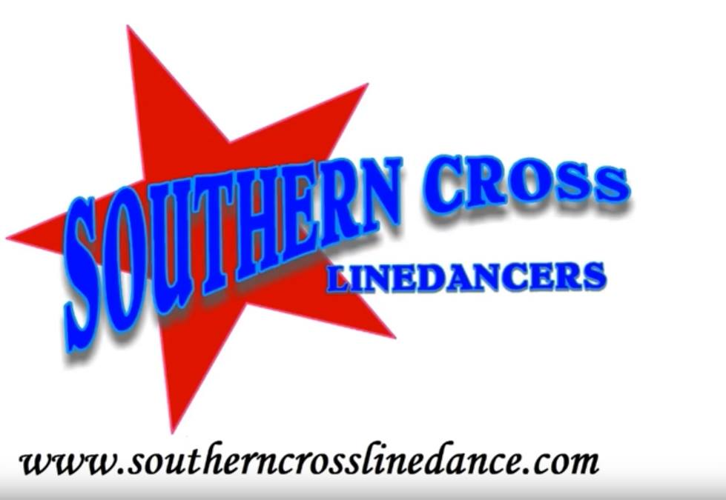
Truck Yeah
Choreographed by Mark Simpkin
Music: No Truck Song by Tim Hicks
Dance Description: 32 Counts, 4 Wall, Improver
Intro: 16 Counts from first heavy beat
3.12mins BPM 122

L Samba – Cross Rock R, Recover – Side Together Cross – L Kick Ball Cross
1&2 Step L fwd, Step R to R side, Recover L (Samba Step)
3-4 Cross Rock R over L, Recover L
5&6 Step R to R side, Step L together, Cross R over L
7&8 Kick L forward, Step L beside R, Cross R over L, (kick ball cross)
Counts 3-8 are danced facing the L diagonal

Side Shuffle L– Rock Back Recover – Monterey 1/2 R – 1/4 L/Hook L
1&2, Step L to L side, Step R together, Step L to L side (side shuffle)
3-4 Rock R back, Recover L
5-6-7 Point R to R side, 1/2 R stepping down on R, Point L to L side, (6:00)
8 Pivot 1/4 L with weight on R foot while hooking L foot (3:00)

L Toe Strut – 1/2 L Shuffle – Rock Back Recover – Out Out Ball Cross
1-2 L toe strut forward
3&4 Turn 1/4 L stepping R to R side, L together, Turn 1/4 L stepping R back (9:00)
5-6 Rock L back, Recover R
&7&8 Step L to L side, Step R to R side, L together, Cross R over L

Side Shuffle 1/4 R – Rock Back Recover – Full Turn L – Side Shuffle 1/4 L
1&2 Step L to L side, R together, Turn 1/4 R stepping L back, (side shuffle with a quarter) (12:00)
3-4 R back, Recover L,
5-6 Turn 1/2 L stepping R back, Turn 1/2 L stepping L forward
7&8 Turn 1/4 L stepping R to R side, Step L together R, Step R to R side (9:00)

On wall 9 there is a false ending; just keep to tempo and dance through.

Mark Simpkin – Southern Cross Line Dancers – www.southerncrosslinedance.com
msimpkin@bigpond.net.au M 0418 440 402

