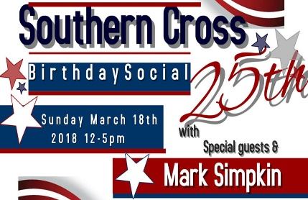
Southern Cross 25th Birthday Social
PLAYLIST

Bracket 1 Mark Simpkin, Maria & Kevin  Cowboy Cha Cha  I Love a Rainy Night  It’s Working  Penny Arcade  Who Do You Call Darling?  Champagne Promise  Winner at A Losing Game  Requests… | Bracket 6 Butch, Charlie & Lindsay  Dance with Me/Crash & Burn  You Ain’t Here  Be That Song  No Matter What  Champagne on Ice  Deep River  Requests…
Bracket 2 Mark & Tracie  Hot Tamales/Hot Tamales Junior  Cowboy Boots/Beginner Boots  Lonely Drum  Midnight Waltz  I Remember  Pride  Requests… | Bracket 7 Simon & Tracie  Titanic/Gin & Tonic  Tulsa Slide  Out of Control  Girls Night Out  Badge of Honour  Requests…
Bracket 3 Mark, Kelvin & Wendy  Gypsy Lady  Stomp  Dance Ranch Romp  Lonely Girl  She Said Yes  The Ride  Requests… | Bracket 8 Tracie, Maria & Penny  Lovestruck/Dumbstruck  Blue Ain’t Your Colour  Too Much Cha  Fly Like a Bird  Remember When  Black Coffee  Requests…
Bracket 4 Mark & Simon Ward  Thinkin’ Country  Making History  Like It or Lump It  Against All Odds  Lady in Red  Beautiful in My Eyes  Requests… | Bracket 9 Mark & Peter Fry  That’s Nice  Wishful Thinking  High & Dry  Water Off a Duck’s Back  Wolves  Lay Low  Requests…
Bracket 5 Julie, Jenny & Wendy  Come Dance with Me  Come wake Me up  Patient Heart  Bayou City Twister  Dive/Don’t Call Me Baby  Requests… | Bracket 10 Mark Simpkin & Tracie  Hung the Moon  Get Gone  Jambalaya  Rock Around the Clock  I Know You Won’t  Cowboy & Clown  Requests…

