Get To Know Ya

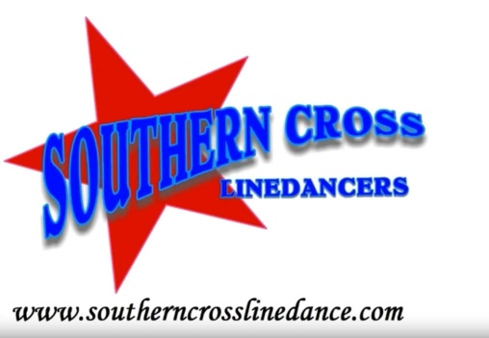
Count: 48 Wall: 2 Level: Intermediate
Choreographer: Mark Simpkin – for Winter Wipeout 2022 – ver 1
Music: Get To Know Ya (Acoustic) by Casey Barnes
Music Available on iTunes – 3:40 min / 85 BPM
(Intro 16 counts on lyrics)
S1: R BACK, L BACK COASTER STEP, BALL STEP, R PIVOT, 1/2 R TURNING LOCK/SWEEP R, STEP R BEHIND, L SIDE 1 2 & 3 Step R back, Step L back, Step R beside L, Step L forward (coaster step)
& 4 5 Step R beside L, Step L forward, Pivot 1/2 R (6.00)
6 & 7 Turn 1/4 R stepping on L, Turn 1/4 R cross stepping R over L, Step L back as R foot sweeps in an arc.
8 & Step R slightly behind L, Step L to L side
S2: CROSS R OVER L, RECOVER L, R SIDE, CROSS L OVER R, RECOVER R WHILE SWEEPING L, L BEHIND, STEP R OUT, STEP L OUT, BALL, CROSS L OVER R, UNWIND FULL TURN R KEEPING WEIGHT ON L
1 2 & Cross R over L, Recover L, Step R to R side
3 4 Cross L over R, Recover to R as L foot sweeps to L side
5 & 6 Step L behind R, Step out R to R side, Step L out to L side (L sailor)
& 7 8 Step R beside L, Cross L over R keeping weight on L, Unwind a full turn R keeping weight on L
S3: 1/4 R SHUFFLE, 1/2 R, ROCK R BACK, RECOVER L, WALK R, WALK L, 1/4 L SIDE R SHUFFLE
1 & 2 Step R to R side, Step L beside R, turn 1/4 R stepping R forward (3.00)
& 3 4 Turn 1/2 R stepping L back, Step R back (1/2 turn ball step) , Recover L forward (9.00)
5 6 Step R forward slightly crossing over L for styling, Step L forward slightly crossing over R for styling
7 & 8 Turn 1/4 L stepping R to R side, L together, Step R to R side (R side shuffle) (6:00)
S4: HINGE L 1/2 BALL CROSS, RECOVER L, 1/4 R, SPIRAL FULL TURN, FWD R SHUFFLE, BALL STEP BACK SWEEP,
L BEHIND, ROLLING 1 1/4 TURN OVER R
& 1 2 Hinge L 1/2 turn over L step on ball of L, Cross/Rock R over L, Recover back L (12.00)
& 3 4 & 5 1/4 turn R on R, Step fwd on L Spiral full turn over R, Shuffle forward R, L, R (3.00)
& 6 Ball Step L together, Step back on R sweeping L around,
7 & 8 & Step L behind R, 1/4 R Step forward R, 1/2 turn R step back L, 1/2 turn R step forward R (6.00)

S5: STEP L FORWARD, RECOVER R, 1/2 TURNING L SHUFFLE, SWITCH 1/4 L ON R, BACK L RECOVER R
1/2 TURN R ON L, ROCK BACK R, RECOVER FORWARD ON L
1 2 3 & 4 Rock fwd on L, Replace weight back on R, 1/4 turn L step L to side, step R tog, 1/4 L step L forward (1/2 shuffle) (12.00)
& 5 6 1/4 turn L step on R, Rock back L, Replace weight forward wd on R, (9.00)
& 7 8 1/2 turn over R step on L, Rock Back on R, Replace weight forward on L (3.00)
S6: WALKING 3 STEPS FWD R L R TURNING OVER L 1/2 1/2 ,1/2 , L COASTER, OUT, OUT, BALL CROSS,
UNWIND 3/4 TURN OVER R WGT ON L
1 2 3 Turn 1/2 L stepping R back, Turn 1/2 L stepping L forward, Turn 1/2 L stepping R back
4 & 5 Step L back, Step R beside L, Step L forward (coaster step) (9.00)
& 6 Step R out to R side, Step L out to L side
& 7 8 R together, Cross L over R, Unwind 3/4 turn over R weight on L (6.00)
Mark Simpkin – Southern Cross Line Dancers – www.southerncrosslinedance.com
msimpkin@bigpond.net.au M 0418 440 402
YouTube - Southern Cross Linedancers

