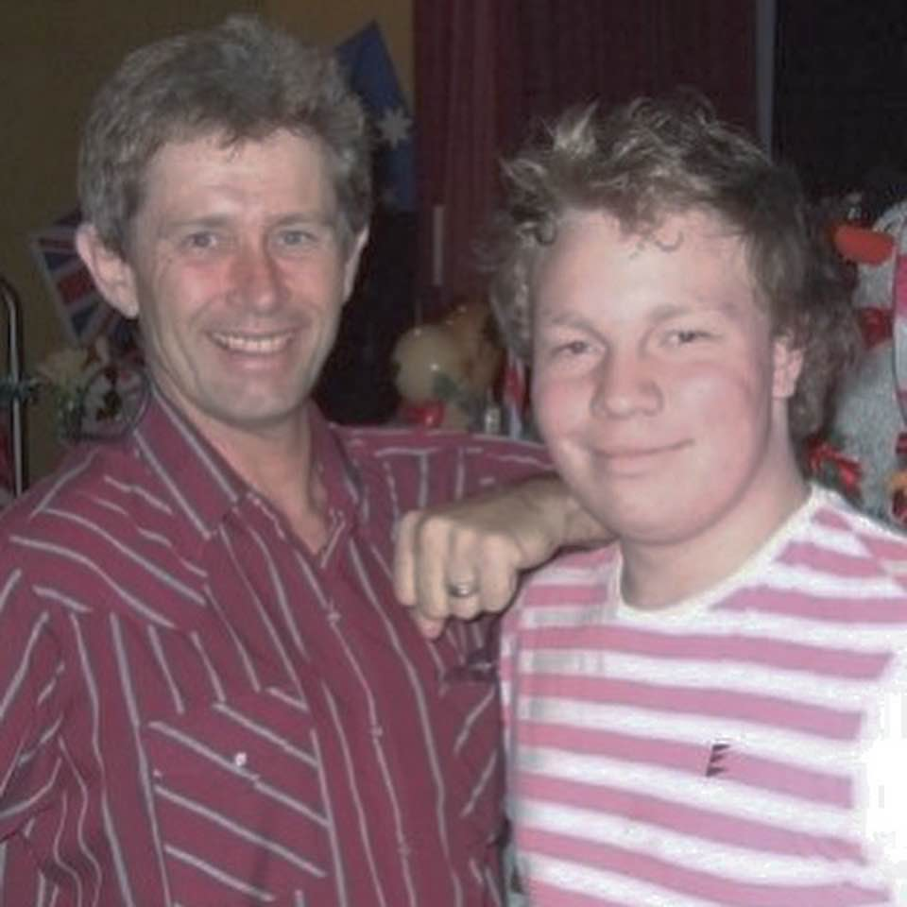
Like A Rodeo
Choreographed by Mark Simpkin & Travis Taylor (July 19)
Music: Like A Rodeo by Kane Brown
Dance Description: 64 Counts, 2 Walls, Higher Intermediate Line Dance
Intro: 16 Counts from first heavy beat

Mambo Sweep – Behind & Cross – Point & Rock & Cross Quarter Half
1&2 Rock R fwd, Replace weight on L, Step R back sweeping L around
3&4 Step L behind R, Step R to R side, Cross L over R
5&6& Point R to R side, Step R together, Rock L to L side, Replace weight on R
7&8 Cross L over R, 1/4 L Stepping R back, 1/2 L Stepping L fwd (3:00)

Mambo Sweep – Behind & Cross – Point & 1/2 R Side Rock & Cross Quarter Back Lock
1&2 Rock R fwd, Replace weight on L, Step R back sweeping L around
3&4 Step L behind R, Step R to R side, Cross L over R
5&6& Point R to R side, 1/4 R Stepping R together, 1/4 R Rock L to L side, Replace weight on R (9:00)
7&8& Cross L over R, 1/4 L Stepping R back, Step L back, Lock R over L (6:00)

Back/Sweep – Back Rock– Half Half Quarter Side – Behind & Cross & Replace Cross Side
1-2& Step back on L sweeping R around, Rock R back, Replace weight on L
3&4 1/2 L Stepping R back, 1/2 L Stepping L fwd, 1/4 L Stepping R to R side (3:00)
5&6& Step L behind R, Step R to R side, Cross L over R, Step/Rock R to R side
7&8 Replace weight on L, Cross R over L, Step to L side (prepare for the hinge turn on Count 1)

Hinge 3/4 & Step Half & Coaster Step & Back Replace & Full Turn – Step Together
1-2& Replace weight on R as you Hinge a 3/4 turn L, Step L down/fwd, 1/2 L Stepping R back (12:00)
3&4& Step L back, Step R together, Step L fwd, Step/Switch R together
5-6& Rock L back, Replace weight on R, 1/2 R Stepping L back
7-8 1/2 R Stepping R fwd, Step L together (12:00)

Side – Back Replace – Quarter Half Quarter Side – Kick & Cross & Step Together Quarter Side
1-2& Step R to R side dragging L, Rock L back, Replace weight on R
3&4 1/4 R Stepping L back, 1/2 R Stepping R fwd, 1/4 R Stepping L to L side (12:00)
5&6& Kick R on R 45, Step R ball together, Cross L over R, 1/4 L Stepping R back
7&8 1/2 L Stepping L fwd, 1/4 L Stepping R together, Step L to L side dragging R together (no weight change) (12:00)

1/8 Fwd – 1/2 R Pivot & Full Turn Fwd – Replace/Sweep 1/4 L – Back Together – Step & Step 1/2 R Pivot
1-2& 1/8 R Stepping R fwd, Step L fwd, 1/2 R Pivot weight on R (7:30)
3&4 1/2 R Stepping L back, 1/2 R Stepping R fwd, Step/Rock L fwd (7:30)
5-6& Replace weight on R sweeping L into a 1/4 L (4:30), Step L back, Step R together
7&8& Step L fwd, Step R together, Step L fwd, 1/2 R Pivot weight on R (10:30)

3/4 Hinge R - Shuffle & Raise 1/4 R Cross – Side Ball Cross & Behind 1/4 L – Pivot 1/2 L
1& 1/8 R Stepping L to L side (straightening up to 12:00) while also hinging into a 3/4 R (9:00)
2&3-4 Step R fwd, Step L together, Step R fwd, 1/4 R Raising L knee & Crossing L over R (12:00)
5&6& Step R to R side, Step L ball together, Cross R over L, Step L to L side
7&8& Step R behind L, 1/4 L Stepping L fwd, Step R fwd, 1/2 L Pivot weight on L (3:00)

Full Turn – Shuffle & Raise 1/4 L Cross – Side Ball Cross & 1/2 L Unwind
1 1/4 L Stepping R to R side while also hinging into a 3/4 L (3:00)
2&3-4 Step L fwd, Step R together, Step L fwd, 1/4 L Raising R knee & Crossing R over L (4) (12:00)
5&6& Step L to L side, Step R ball together, Cross R over L, Step R to R side
7-8 Touch L toe behind R, 1/2 L dropping L heel/Unwind (6:00)

Mark Simpkin – Southern Cross Line Dancers – southerncrosslinedance.com
Travis Taylor – dancewithtravis@gmail.com

