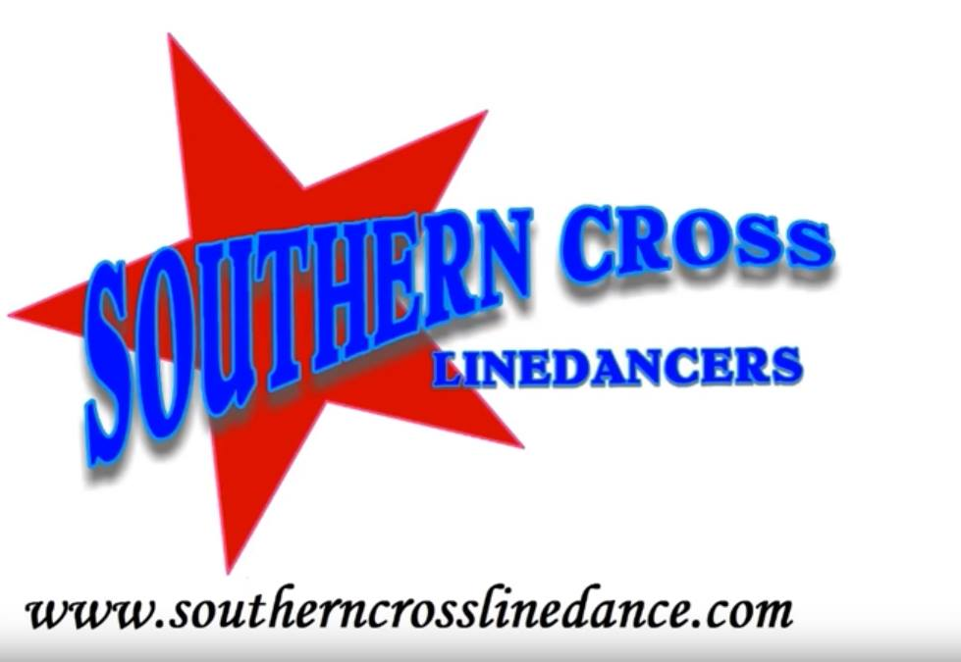
Matching Tattoos
Choreographed by Mark Simpkin - April 2024
Music: Matching Tattoos by Josh Ross
Dance Description: 32 Counts, 2 Walls, Intermediate
Intro: Starts 16 counts in on lyrics. Weight is on R
2.59 mins BPM 78
# Restart wall 5 after 16 counts – 6.00

Version 1

L fwd, Recover R, L beside R, R fwd, 1/4 L pivot, Cross R over L, L to L side, R behind 1/4 L sweep L, L sailor
1 2 &3 4 Step L forward, Recover R, Step L beside R, Step R forward, 1/4 L pivot (wgt on L) (9.00)
5&6 Cross R over L, Step L to L side, Step R behind L turning turn 1/4 L sweeping L around (6.00)
7&8 L behind R, Step R to R side, Step L to L side

R out, L out, Sway R, 1/2 L sailor cross, Ball cross, Fwd R, L fwd coaster, 1/2 R #
&1 2 Step R out to R side, Step L out to L side, Sway R
3&4 Turn 1/2 L stepping L to L side, Step R beside L, Cross L over R (12.00)
&5 Step R to R side, Cross L over R
6 7&8& R forward, Step L forward, R beside L, Step L back, 1/2 R stepping R forward (6.00)

L fwd, 1/2 R pivot, Turning 1/2 R Lock, 1/2 R stepping R fwd, L fwd, Recover R, L scissor
1 2 Step L forward, 1/2 R pivot (12.00)
3&4 Turn 1/4 R stepping L to L side, Turn 1/4 R crossing R over L, Step L back (6.00)
&5 6 Turn 1/2 R stepping forward R, L forward, Recover R (12.00)
7&8 Step L to L side, Recover side R, Cross L over R

Ball, Sway, 1/4 L stepping R back, L back coaster, Fwd R coaster, 1/4 L fwd, R fwd spiral
&1 2 Step R to R side, Sway L, Turn 1/4 L stepping R (9.00)
3&4 Step L back, Step R beside L, Step L forward
5 6& Step R fwd, L beside R, R back
7 8& Turn 1/4 L stepping on L, Step R forward into a L spiral turn

Ending

Mark Simpkin – Southern Cross Line Dancers – www.southerncrosslinedance.com
YouTube – Southern Cross Linedancers
msimpkin@bigpond.net.au M 0418 440 402

