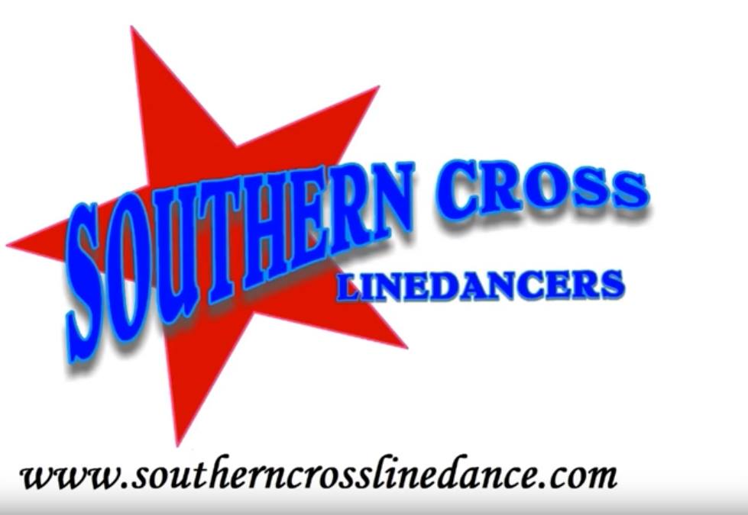
Nothin’ on You
Choreographed by Mark Simpkin
Music: Nothin’ On You by Luke Dickens
Dance Description: 32 Counts, 4 Wall, Improver
Intro: 16 counts on vocals
3.36mins BPM 107
Restart wall 4 facing 9.00 dance the first 16 counts and restart 3.00 and then on wall 9 facing 12.00 dance the first 16 counts and restart at 6.00

R Dorothy Lock – L Shuffle – Recover R – Sweep L into a 1/4 L Coaster – Ball Step L forward
1-2& Step R forward to R diagonal, Lock L behind R, Step R forward to R diagonal
3-4& L forward, Step R beside L, L forward (shuffle L)
5-6&7 Recover R, Sweep L foot around into a 1/4 L coaster, (9.00)
&8 Step R beside L, L forward (ball step)

R forward – Recover – Back 1/4 L Cross – Side Recover – Behind Side Cross
1-2 R forward, Recover L
3&4 R back, 1/4 L stepping L to L side, Cross R over L (6.00)
5-6 Step L to L side, Recover R
7&8 Cross L behind R, Step R to R side, Cross L over R

Ball Cross – Recover R – 1/4 L shuffle – Out Out Sway – Behind Side Cross
&1-2 Ball, Cross L, Recover R,
3& 4 Turn 1/4 L stepping L forward, Step R beside L, Step L forward (3.00)
&5-6 Step R out to R side, Step L out to L side, Sway R
7&8 Step L Behind R, Step R to R side, Cross L over R

Sway R Recover Together – 1/4 L Rock Recover, L Back Coaster – Step R forward 1/4 L pivot
1-2& Sway R to R side, Recover L, Step R beside L
3-4 Turn 1/4 L stepping L forward, Recover R, (12.00)
5&6 Step L back, R together, Step L forward (coaster step)
7-8 Step R forward, Pivot 1/4 L (9.00)

Mark Simpkin – Southern Cross Line Dancers – www.southerncrosslinedance.com
msimpkin@bigpond.net.au M 0418 440 402

