SMOKEY PLACES

Count: 32 Wall: 4 Level: Beginner / Intermediate
Choreographer: Michele Perron
Music: Smokey Places by Ronnie McDowell

SIDE, TOGETHER, STEP, HOLD, SIDE, TOGETHER, BACK, HOLD
1-4 Step left to side, step right together, step left forward, hold
5-8 Step right to side, step left together, step right back, hold
SIDE, TOGETHER, SIDE, HOLD, CROSS, SIDE, CROSS, TOUCH
9-12 Step left to side, step right together, step left to side, hold
13-16 Cross right behind left, step left to side, cross right over left, touch left to side
STEP, TOUCH, STEP, TOUCH, STEP, PIVOT ½, STEP, TOUCH
17-20 Cross left behind right, touch right to side, cross right over left, cross/touch left behind right
21-22 Cross left behind right, turn ½ right and step right forward
23-24 Step left forward, cross/touch right behind left
STEP, PIVOT ½, STEP, TOUCH, STEP, TURN ¼, STEP, SIDE
25-26 Cross right behind left, turn ½ left and step left forward
27-28 Step right forward, cross/touch left behind right
29-30 Cross left behind right, turn ¼ right and step right to side
31-32 Step left together, step right to side
REPEAT

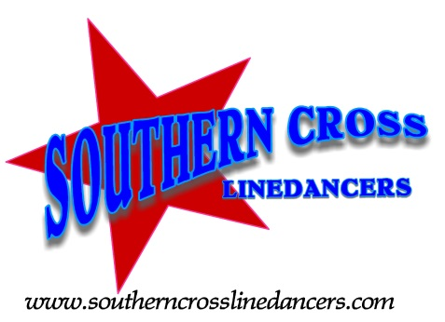

Dance taught by Southern Cross Linedance instructors

